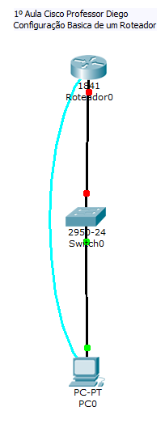
Router>en
Router>enable
Router#config t
Router#config terminal
Enter configuration commands, one per line. End with CNTL/Z.
Router(config)#no ip domain-lookup
Router(config)#hostname SA
SA(config)#enable pa
SA(config)#enable password cisco
SA(config)#enable se
SA(config)#enable secret
% Incomplete command.
SA(config)#enable secret cisco
SA(config)#service pas
SA(config)#service password-encryption
SA(config)#line con
SA(config)#line console 0
SA(config-line)#pas
SA(config-line)#password cisco
SA(config-line)#login
SA(config-line)#exit
SA(config)#line vty 0 4
SA(config-line)#pa
SA(config-line)#pas
SA(config-line)#password cisco
SA(config-line)#login
SA(config-line)#exit
SA(config)#ba
SA(config)#banner lo
SA(config)#banner login #ACESSO RESTRITO#
SA(config)#^Z
SA#
%SYS-5-CONFIG_I: Configured from console by console
wr
Building configuration...
[OK]
SA#cop
SA#copy ru
SA#copy running-config st
SA#copy running-config startup-config
Destination filename [startup-config]?
Building configuration...
[OK]
SA#sho ru
SA#sho running-config
Building configuration...

Current configuration : 655 bytes
!
version 12.4
no service timestamps log datetime msec
no service timestamps debug datetime msec
service password-encryption
!
hostname SA
!
!
!
enable secret 5 $1$mERr$hx5rVt7rPNoS4wqbXKX7m0
enable password 7 0822455D0A16
!
!
!
!
!
!
!
!
!
!
no ip domain-lookup
!
!
spanning-tree mode pvst
!
!
!
!
interface FastEthernet0/0
no ip address
duplex auto
speed auto
shutdown
!
interface FastEthernet0/1
no ip address
duplex auto
speed auto
shutdown
!
interface Vlan1
no ip address
shutdown
!
ip classless
!
!
!
banner login ^CACESSO RESTRITO^C
!
!
!
!
line con 0
password 7 0822455D0A16
login
line vty 0 4
password 7 0822455D0A16
login
!
!
!
end

SA#
SA#config t
SA#config terminal
Enter configuration commands, one per line. End with CNTL/Z.
SA(config)#inter
SA(config)#interface fast
SA(config)#interface fastEthernet 0/0
SA(config-if)#ip ad
SA(config-if)#ip address 192.168.0.1 255.255.255.0
SA(config-if)#des
SA(config-if)#description interface de rede diretoria
SA(config-if)#no sh
SA(config-if)#no shutdown

%LINK-5-CHANGED: Interface FastEthernet0/0, changed state to up

%LINEPROTO-5-UPDOWN: Line protocol on Interface FastEthernet0/0, changed state to up

SA(config-if)#^Z
SA#
%SYS-5-CONFIG_I: Configured from console by console
wr
Building configuration...
[OK]
SA#show ip interface brief
Interface IP-Address OK? Method Status Protocol

FastEthernet0/0 192.168.0.1 YES manual up up

FastEthernet0/1 unassigned YES unset administratively down down

Vlan1 unassigned YES unset administratively down down
SA#copy ru
SA#copy running-config st
SA#copy running-config startup-config
Destination filename [startup-config]?
Building configuration...
[OK]
SA#
SA#

