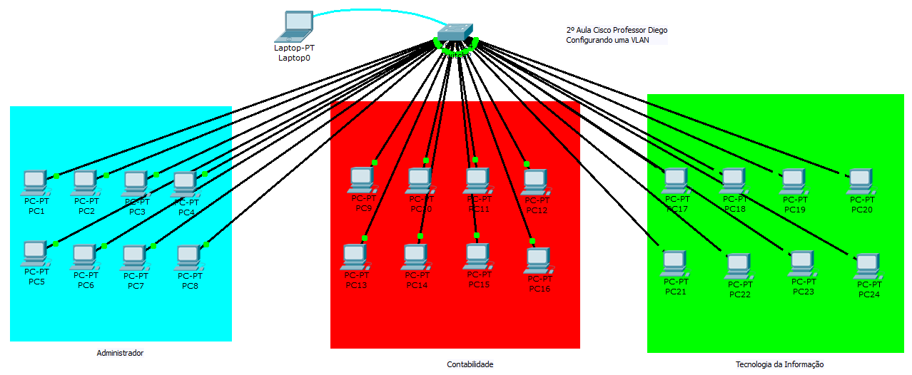
Switch>en
Switch#config t
Enter configuration commands, one per line. End with CNTL/Z.
Switch(config)#hostname TECHINFO
TECHINFO(config)#vlan 2
TECHINFO(config-vlan)#name ADM
TECHINFO(config-vlan)#exit
TECHINFO(config)#vlan 3
TECHINFO(config-vlan)#name CONTABIL
TECHINFO(config-vlan)#exit
TECHINFO(config)#vlan 4
TECHINFO(config-vlan)#name TI
TECHINFO(config-vlan)#exit
TECHINFO(config)#int fa0/1
TECHINFO(config-if)#sw
TECHINFO(config-if)#switchport ac
TECHINFO(config-if)#switchport access vl
TECHINFO(config-if)#switchport access vlan 2
TECHINFO(config-if)#int fa0/2
TECHINFO(config-if)#switchport access vlan 2
TECHINFO(config-if)#int fa0/3
TECHINFO(config-if)#switchport access vlan 2
TECHINFO(config-if)#int fa0/4
TECHINFO(config-if)#switchport access vlan 2
TECHINFO(config-if)#int fa0/5
TECHINFO(config-if)#switchport access vlan 2
TECHINFO(config-if)#int fa0/6
TECHINFO(config-if)#switchport access vlan 2
TECHINFO(config-if)#int fa0/7
TECHINFO(config-if)#switchport access vlan 2
TECHINFO(config-if)#int fa0/8
TECHINFO(config-if)#switchport access vlan 2
TECHINFO(config-if)#exit
TECHINFO(config)#int fa0/9
TECHINFO(config-if)#switchport access vlan 3
TECHINFO(config-if)#int fa0/10
TECHINFO(config-if)#switchport access vlan 3
TECHINFO(config-if)#int fa0/11
TECHINFO(config-if)#switchport access vlan 3
TECHINFO(config-if)#int fa0/12
TECHINFO(config-if)#switchport access vlan 3
TECHINFO(config-if)#int fa0/13
TECHINFO(config-if)#switchport access vlan 3
TECHINFO(config-if)#int fa0/14
TECHINFO(config-if)#switchport access vlan 3
TECHINFO(config-if)#int fa0/15
TECHINFO(config-if)#switchport access vlan 3
TECHINFO(config-if)#int fa0/16
TECHINFO(config-if)#switchport access vlan 3
TECHINFO(config-if)#int fa0/16
TECHINFO(config-if)#switchport access vlan 3
TECHINFO(config-if)#exit
TECHINFO(config)#int fa0/17
TECHINFO(config-if)#switchport access vlan 4
TECHINFO(config-if)#int fa0/18
TECHINFO(config-if)#switchport access vlan 4
TECHINFO(config-if)#int fa0/19
TECHINFO(config-if)#switchport access vlan 4
TECHINFO(config-if)#int fa0/20
TECHINFO(config-if)#switchport access vlan 4
TECHINFO(config-if)#int fa0/21
TECHINFO(config-if)#switchport access vlan 4
TECHINFO(config-if)#int fa0/22
TECHINFO(config-if)#switchport access vlan 4
TECHINFO(config-if)#int fa0/23
TECHINFO(config-if)#switchport access vlan 4
TECHINFO(config-if)#int fa0/24
TECHINFO(config-if)#switchport access vlan 4
TECHINFO(config-if)#exit
TECHINFO(config)#^Z
TECHINFO#
%SYS-5-CONFIG_I: Configured from console by console
wr
Building configuration...
[OK]
TECHINFO#copy ru
TECHINFO#copy running-config st
TECHINFO#copy running-config startup-config
Destination filename [startup-config]?
Building configuration...
[OK]
TECHINFO#

Observação: Para testar as vlans tem que colocar ip fixo em cada maquina

