VLAN com DHCP
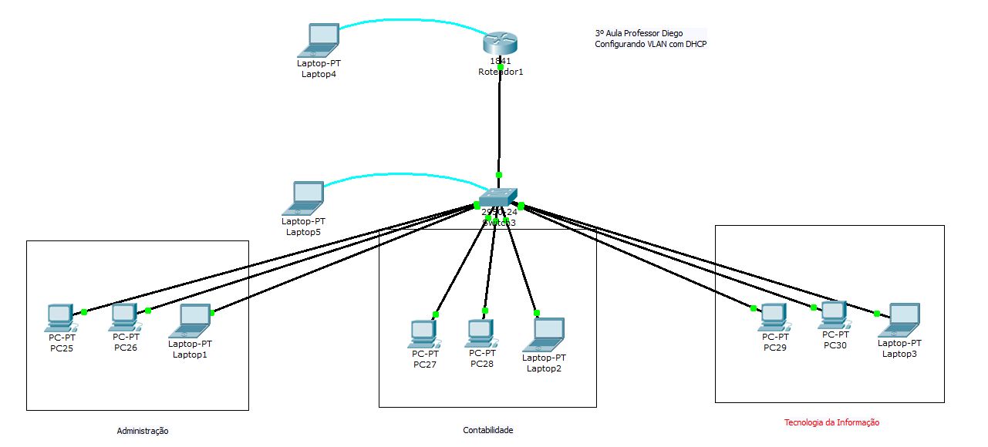

1º Configurando as VLAN no switch
Switch>en
Switch#config t
Switch#config terminal
Enter configuration commands, one per line. End with CNTL/Z.
Switch(config)#no ip domain-lookup
Switch(config)#vlan 2
Switch(config-vlan)#name ADM
Switch(config-vlan)#exit
Switch(config)#vlan 3
Switch(config-vlan)#name CONTABIL
Switch(config-vlan)#exit
Switch(config)#vlan 4
Switch(config-vlan)#name TI
Switch(config-vlan)#exit
Switch(config)#int fa0/2
Switch(config-if)#sw
Switch(config-if)#switchport ac
Switch(config-if)#switchport access vl
Switch(config-if)#switchport access vlan 2
Switch(config-if)#int fa0/3
Switch(config-if)#switchport access vlan 2
Switch(config-if)#int fa0/4
Switch(config-if)#switchport access vlan 2
Switch(config-if)#exit
Switch(config)#int fa0/9
Switch(config-if)#sw
Switch(config-if)#switchport ac
Switch(config-if)#switchport access vl
Switch(config-if)#switchport access vlan 3
Switch(config-if)#int fa0/10
Switch(config-if)#switchport access vlan 3
Switch(config-if)#int fa0/11
Switch(config-if)#switchport access vlan 3
Switch(config-if)#exit
Switch(config)#int fa0/17
Switch(config-if)#switchport access vlan 4
Switch(config-if)#int fa0/18
Switch(config-if)#switchport access vlan 4
Switch(config-if)#int fa0/19
Switch(config-if)#switchport access vlan 4
Switch(config)#int fa0/1
Switch(config-if)#sw
Switch(config-if)#switchport mo
Switch(config-if)#switchport mode tr
Switch(config-if)#switchport mode trunk

%LINEPROTO-5-UPDOWN: Line protocol on Interface FastEthernet0/1, changed state to down

%LINEPROTO-5-UPDOWN: Line protocol on Interface FastEthernet0/1, changed state to up
Switch(config-if)#exit
Switch(config)#^Z
Switch#
%SYS-5-CONFIG_I: Configured from console by console
wr
Building configuration...
[OK]
Switch#copy ru
Switch#copy running-config st
Switch#copy running-config startup-config
Destination filename [startup-config]?
Building configuration...
[OK]
Switch#show vl
Switch#show vlan br
Switch#show vlan brief

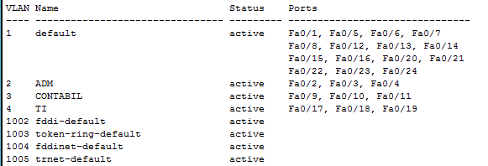

2º Configurando o Router com o serviço de DHCP
Router>en
Router>enable
Router#config t
Router#config terminal
Enter configuration commands, one per line. End with CNTL/Z.
Router(config)#no ip domain-lookup
Router(config)#ip dh
Router(config)#ip dhcp po
Router(config)#ip dhcp pool ADM
Router(dhcp-config)#net
Router(dhcp-config)#network 192.168.1.0 255.255.255.0
Router(dhcp-config)#de
Router(dhcp-config)#default-router 192.168.1.1
Router(dhcp-config)#dns
Router(dhcp-config)#dns-server 1.1.1.1
Router(dhcp-config)#exit
Router(config)#ip dh
Router(config)#ip dhcp po
Router(config)#ip dhcp pool CONATBIL
Router(dhcp-config)#net
Router(dhcp-config)#network 192.168.2.0 255.255.255.0
Router(dhcp-config)#de
Router(dhcp-config)#default-router 192.168.2.1
Router(dhcp-config)#dns
Router(dhcp-config)#dns-server 2.2.2.2
Router(dhcp-config)#exit
Router(config)#ip dh
Router(config)#ip dhcp po
Router(config)#ip dhcp pool TI
Router(dhcp-config)#net
Router(dhcp-config)#network 192.168.3.0 255.255.255.0
Router(dhcp-config)#de
Router(dhcp-config)#default-router 192.168.3.0
Router(dhcp-config)#dns 3.3.3.3
Router(dhcp-config)#exit
Router(config)#int fa0/0
Router(config-if)#no sh
Router(config-if)#no shutdown

%LINK-5-CHANGED: Interface FastEthernet0/0, changed state to up

%LINEPROTO-5-UPDOWN: Line protocol on Interface FastEthernet0/0, changed state to up

Router(config-if)#exit
Router(config)#int fa0/0.2

%LINK-5-CHANGED: Interface FastEthernet0/0.2, changed state to up

%LINEPROTO-5-UPDOWN: Line protocol on Interface FastEthernet0/0.2, changed state to up
Router(config-subif)#en
Router(config-subif)#encapsulation do
Router(config-subif)#encapsulation dot1Q 2
Router(config-subif)#ip ad
Router(config-subif)#ip address 192.168.1.1 255.255.255.0
Router(config-subif)#exit
Router(config)#int fa0/0.9

%LINK-5-CHANGED: Interface FastEthernet0/0.9, changed state to up

%LINEPROTO-5-UPDOWN: Line protocol on Interface FastEthernet0/0.9, changed state to up
Router(config-subif)#en
Router(config-subif)#encapsulation do
Router(config-subif)#encapsulation dot1Q 3
Router(config-subif)#ip
Router(config-subif)#ip ad
Router(config-subif)#ip address 192.168.2.1 255.255.255.0
Router(config-subif)#exit
Router(config)#int fa0/0.17
Router(config-subif)#
%LINK-5-CHANGED: Interface FastEthernet0/0.17, changed state to up

%LINEPROTO-5-UPDOWN: Line protocol on Interface FastEthernet0/0.17, changed state to up

Router(config-subif)#en
Router(config-subif)#encapsulation do
Router(config-subif)#encapsulation dot1Q 4
Router(config-subif)#ip ad
Router(config-subif)#ip address 192.168.3.1 255.255.255.0
Router(config-subif)#exit
Router(config)#^Z
Router#
%SYS-5-CONFIG_I: Configured from console by console
wr
Building configuration...
[OK]
Router#copy ru
Router#copy running-config st
Router#copy running-config startup-config
Destination filename [startup-config]?
Building configuration...
[OK]
Router#

