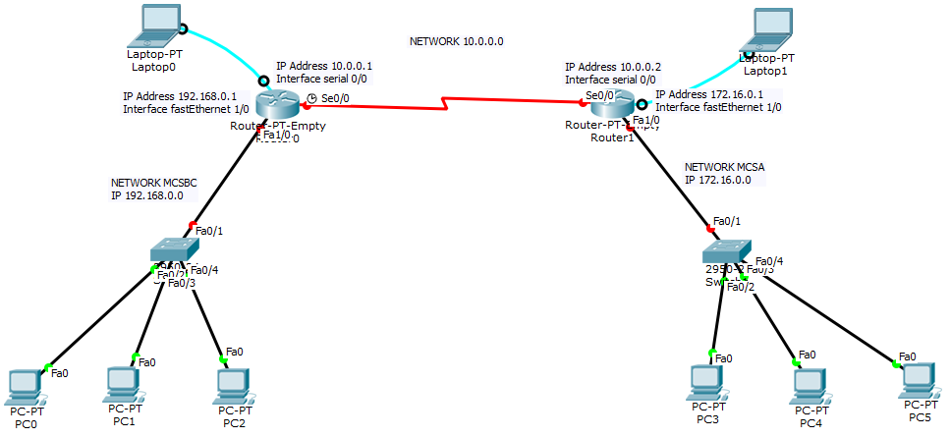
Configuração Roteador MCSBC
Router>
Router>enable
Router#configure terminal
Enter configuration commands, one per line. End with CNTL/Z.
Router(config)#no ip domain-lookup
Router(config)#ip dhcp pool MCSBC
Router(dhcp-config)#network 192.168.0.0 255.255.255.0
Router(dhcp-config)#default-router 192.168.0.1
Router(dhcp-config)#exit
Router(config)#ip dhcp excluded-address 192.168.0.1 192.168.0.50
Router(config)#interface fastEthernet 1/0
Router(config-if)#ip address 192.168.0.1 255.255.255.0
Router(config-if)#no shutdown
Router(config-if)#
%LINK-5-CHANGED: Interface FastEthernet1/0, changed state to up
%LINEPROTO-5-UPDOWN: Line protocol on Interface FastEthernet1/0, changed state to up
Router(config-if)#exit
Router(config)#interface serial 0/0
Router(config-if)#ip address 10.0.0.1 255.0.0.0

Router(config-if)#clock rate 64000
Router(config-if)#no shutdown
%LINK-5-CHANGED: Interface Serial0/0, changed state to down
Router(config-if)#exit
Router(config)#^Z
Router#
%SYS-5-CONFIG_I: Configured from console by console
Router#wr
Building configuration...
[OK]
Router#copy running-config startup-config
Destination filename [startup-config]?
Building configuration...
[OK]
Router#
Configurando a Rota OSPF
Router#configure terminal
Enter configuration commands, one per line. End with CNTL/Z.
Router(config)#router ospf 1
Router(config-router)#network 10.0.0.0 0.255.255.255 area 0
Router(config-router)#network 192.168.0.0 0.0.0.255 area 0
Router(config-router)#^Z
Router#
%SYS-5-CONFIG_I: Configured from console by console

Router#wr
Building configuration...
[OK]
Router#copy running-config startup-config
Destination filename [startup-config]?
Building configuration...
[OK]
Router#
Router#show ip route

Codes: C - connected, S - static, I - IGRP, R - RIP, M - mobile, B - BGP
D - EIGRP, EX - EIGRP external, O - OSPF, IA - OSPF inter area
N1 - OSPF NSSA external type 1, N2 - OSPF NSSA external type 2
E1 - OSPF external type 1, E2 - OSPF external type 2, E - EGP
i - IS-IS, L1 - IS-IS level-1, L2 - IS-IS level-2, ia - IS-IS inter area
* - candidate default, U - per-user static route, o - ODR
P - periodic downloaded static route

Gateway of last resort is not set

C 10.0.0.0/8 is directly connected, Serial0/0
O 172.16.0.0/16 [110/65] via 10.0.0.2, 00:02:11, Serial0/0
C 192.168.0.0/24 is directly connected, FastEthernet1/0

Configuração Roteador MCSA
Router>enable
Router#configure terminal
Enter configuration commands, one per line. End with CNTL/Z.
Router(config)#no ip domain-lookup
Router(config)#ip dhcp pool MCSA
Router(dhcp-config)#network 172.16.0.0 255.255.0.0
Router(dhcp-config)#default-router 172.16.0.1
Router(dhcp-config)#exit
Router(config)#ip dhcp excluded 172.16.0.1 172.16.0.50
Router(config)#interface fastEthernet 1/0
Router(config-if)#ip address 172.16.0.1 255.255.0.0
Router(config-if)#no shutdown
Router(config-if)#
%LINK-5-CHANGED: Interface FastEthernet1/0, changed state to up
%LINEPROTO-5-UPDOWN: Line protocol on Interface FastEthernet1/0, changed state to up
Router(config-if)#exit
Router(config)#interface serial 0/0
Router(config-if)#ip address 10.0.0.2 255.0.0.0

Router(config-if)#no shutdown
Router(config-if)#
%LINK-5-CHANGED: Interface Serial0/0, changed state to up
Router(config-if)#
%LINEPROTO-5-UPDOWN: Line protocol on Interface Serial0/0, changed state to up
Router(config-if)#^Z (CTRL + Z)
Router#
%SYS-5-CONFIG_I: Configured from console by console
Router#wr
Building configuration...
[OK]
Router#copy running-config startup-config
Destination filename [startup-config]?
Building configuration...
[OK]
Router#
Configurando Rota RIP
Router#configure terminal
Enter configuration commands, one per line. End with CNTL/Z.
Router(config)#router ospf 1
Router(config-router)#network 10.0.0.0 0.255.255.255 area 0
Router(config-router)#network
02:12:54: %OSPF-5-ADJCHG: Process 1, Nbr 192.168.0.1 on Serial0/0 from LOADING to FULL, Loadi
Router(config-router)#network 172.16.0.0 0.0.255.255 area 0
Router(config-router)#^Z
Router#
%SYS-5-CONFIG_I: Configured from console by console
Router#wr
Building configuration...
[OK]
Router#copy running-config startup-config
Destination filename [startup-config]?
Building configuration...
[OK]
Router#
Router#show ip route
Codes: C - connected, S - static, I - IGRP, R - RIP, M - mobile, B - BGP
D - EIGRP, EX - EIGRP external, O - OSPF, IA - OSPF inter area
N1 - OSPF NSSA external type 1, N2 - OSPF NSSA external type 2
E1 - OSPF external type 1, E2 - OSPF external type 2, E - EGP
i - IS-IS, L1 - IS-IS level-1, L2 - IS-IS level-2, ia - IS-IS inter area
* - candidate default, U - per-user static route, o - ODR
P - periodic downloaded static route

Gateway of last resort is not set

C 10.0.0.0/8 is directly connected, Serial0/0
C 172.16.0.0/16 is directly connected, FastEthernet1/0
O 192.168.0.0/24 [110/65] via 10.0.0.1, 00:02:13, Serial0/0

